Using the RIE Algorithmes web site and the Phone application
Restaurant opening times: 11h45 to 14h00
YOU can significantly reduce the waiting time when it's time to pay, by having enough money on your account and not having to recharge your badge when there is already a long waiting line
- Use the toqla web site and phone application to add money
- You can also add money to your account on the automated station, with a credit card and a contact-less payment

Creating your account
It is very easy to create an account on the following portal, and add money online: https://app.toqla.fr/
The web site is available in English, if your browser language is set to English!
You can also change the language in the COMPTE (FR) or MY ACCOUNT (EN), and then My profile settings' page.
- You have to know your restaurant badge number
  - This is NOT the CEA badge number, but the number printed on your restaurant receipt
  - The receipts are not printed by default any longer: you have to ask the cashier to print the receipt once, and bring this receipt back with you.
- You have to link your account to your restaurant badge number the first time you use the web site
  - Activate my services ⇒ Activate my corporate restaurant services / Activate my meal voucher services
  - Activer mes services ⇒ Activer mes services de restauration d’entreprise / Activer mes services Titres Restaurant
- When adding a new restaurant/site, you have to look for CEA and RIE SAINT AUBIN

Managing your account

Account management on the web site
Try to access the English version of the SoHappy web site, or ask a French speaking colleague to help you select the English version.
You will then be able to easily manage your account settings (and select the English language), add money (remotely) and specify when you want to receive mails telling you that there is not enough money left on your account.
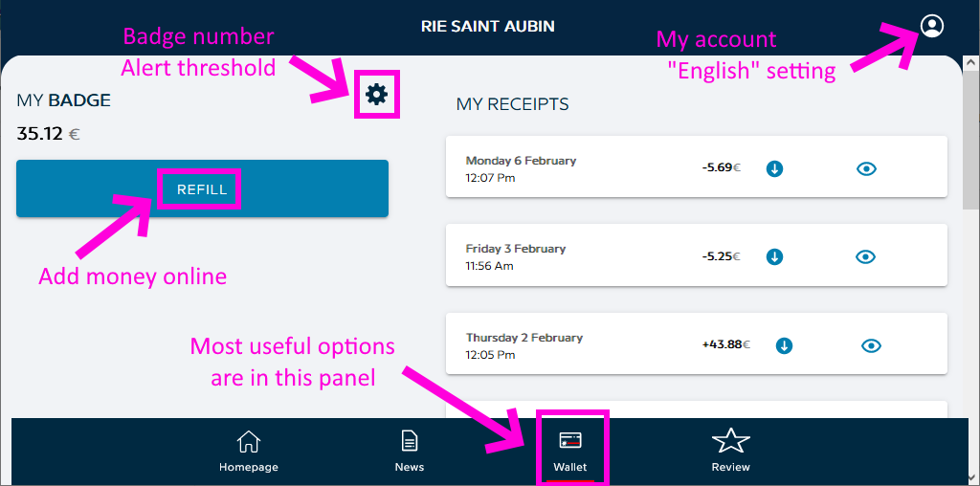

Account management in the phone app
You can also manage your settings and refill your account directly in the SoHappy app.
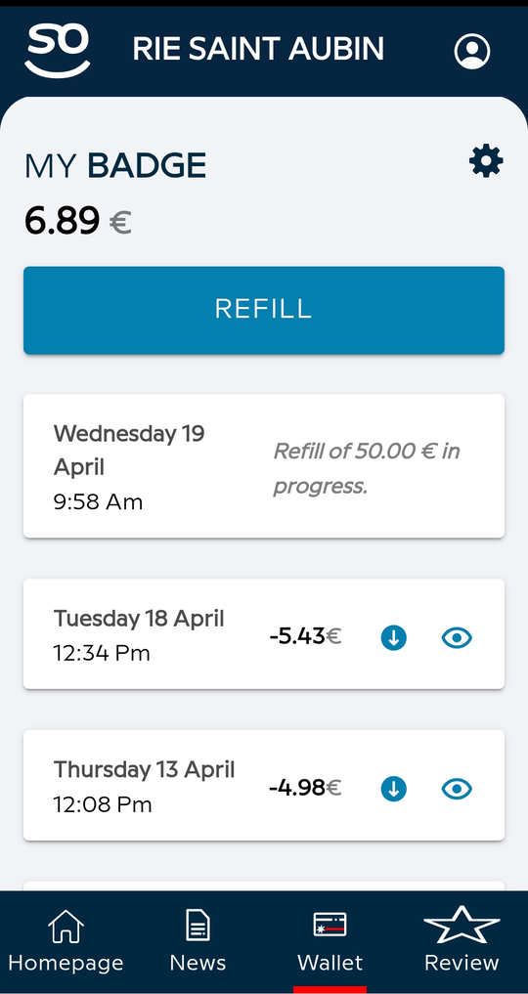

Managing the dishes

Theory...
You are supposed to eat in the restaurant and leave the dishes in the restaurant
There are several options if you want to eat outside of the restaurant:
- Bring your own (empty) lunch box(es) to the restaurant
- Buy (recyclable?) lunch boxes at the restaurant
- Not recommended: bring restaurant dishes (glasses, plates, etc…) back to LSCE
  - in that case, you have to bring the dishes back to the restaurant later (the next day, not at the end of your contract

... and Practice
- In the unlikely case where you borrow dishes from the restaurant
  - You can put them in the the designated dirty dishes trays…
There is a tray conveniently located near the coffee machine on the 1st floor of the 714 building
    - …And later bring a tray with some dishes back to the restaurant!
      - If you don't bring the dishes back, it is called stealing, not borrowing
      - Do not wait for the tray to be full before bringing the dishes back
Do not wait for somebody else to do your dirty work
        - It may seem incredible, but other people also have some important things to finish
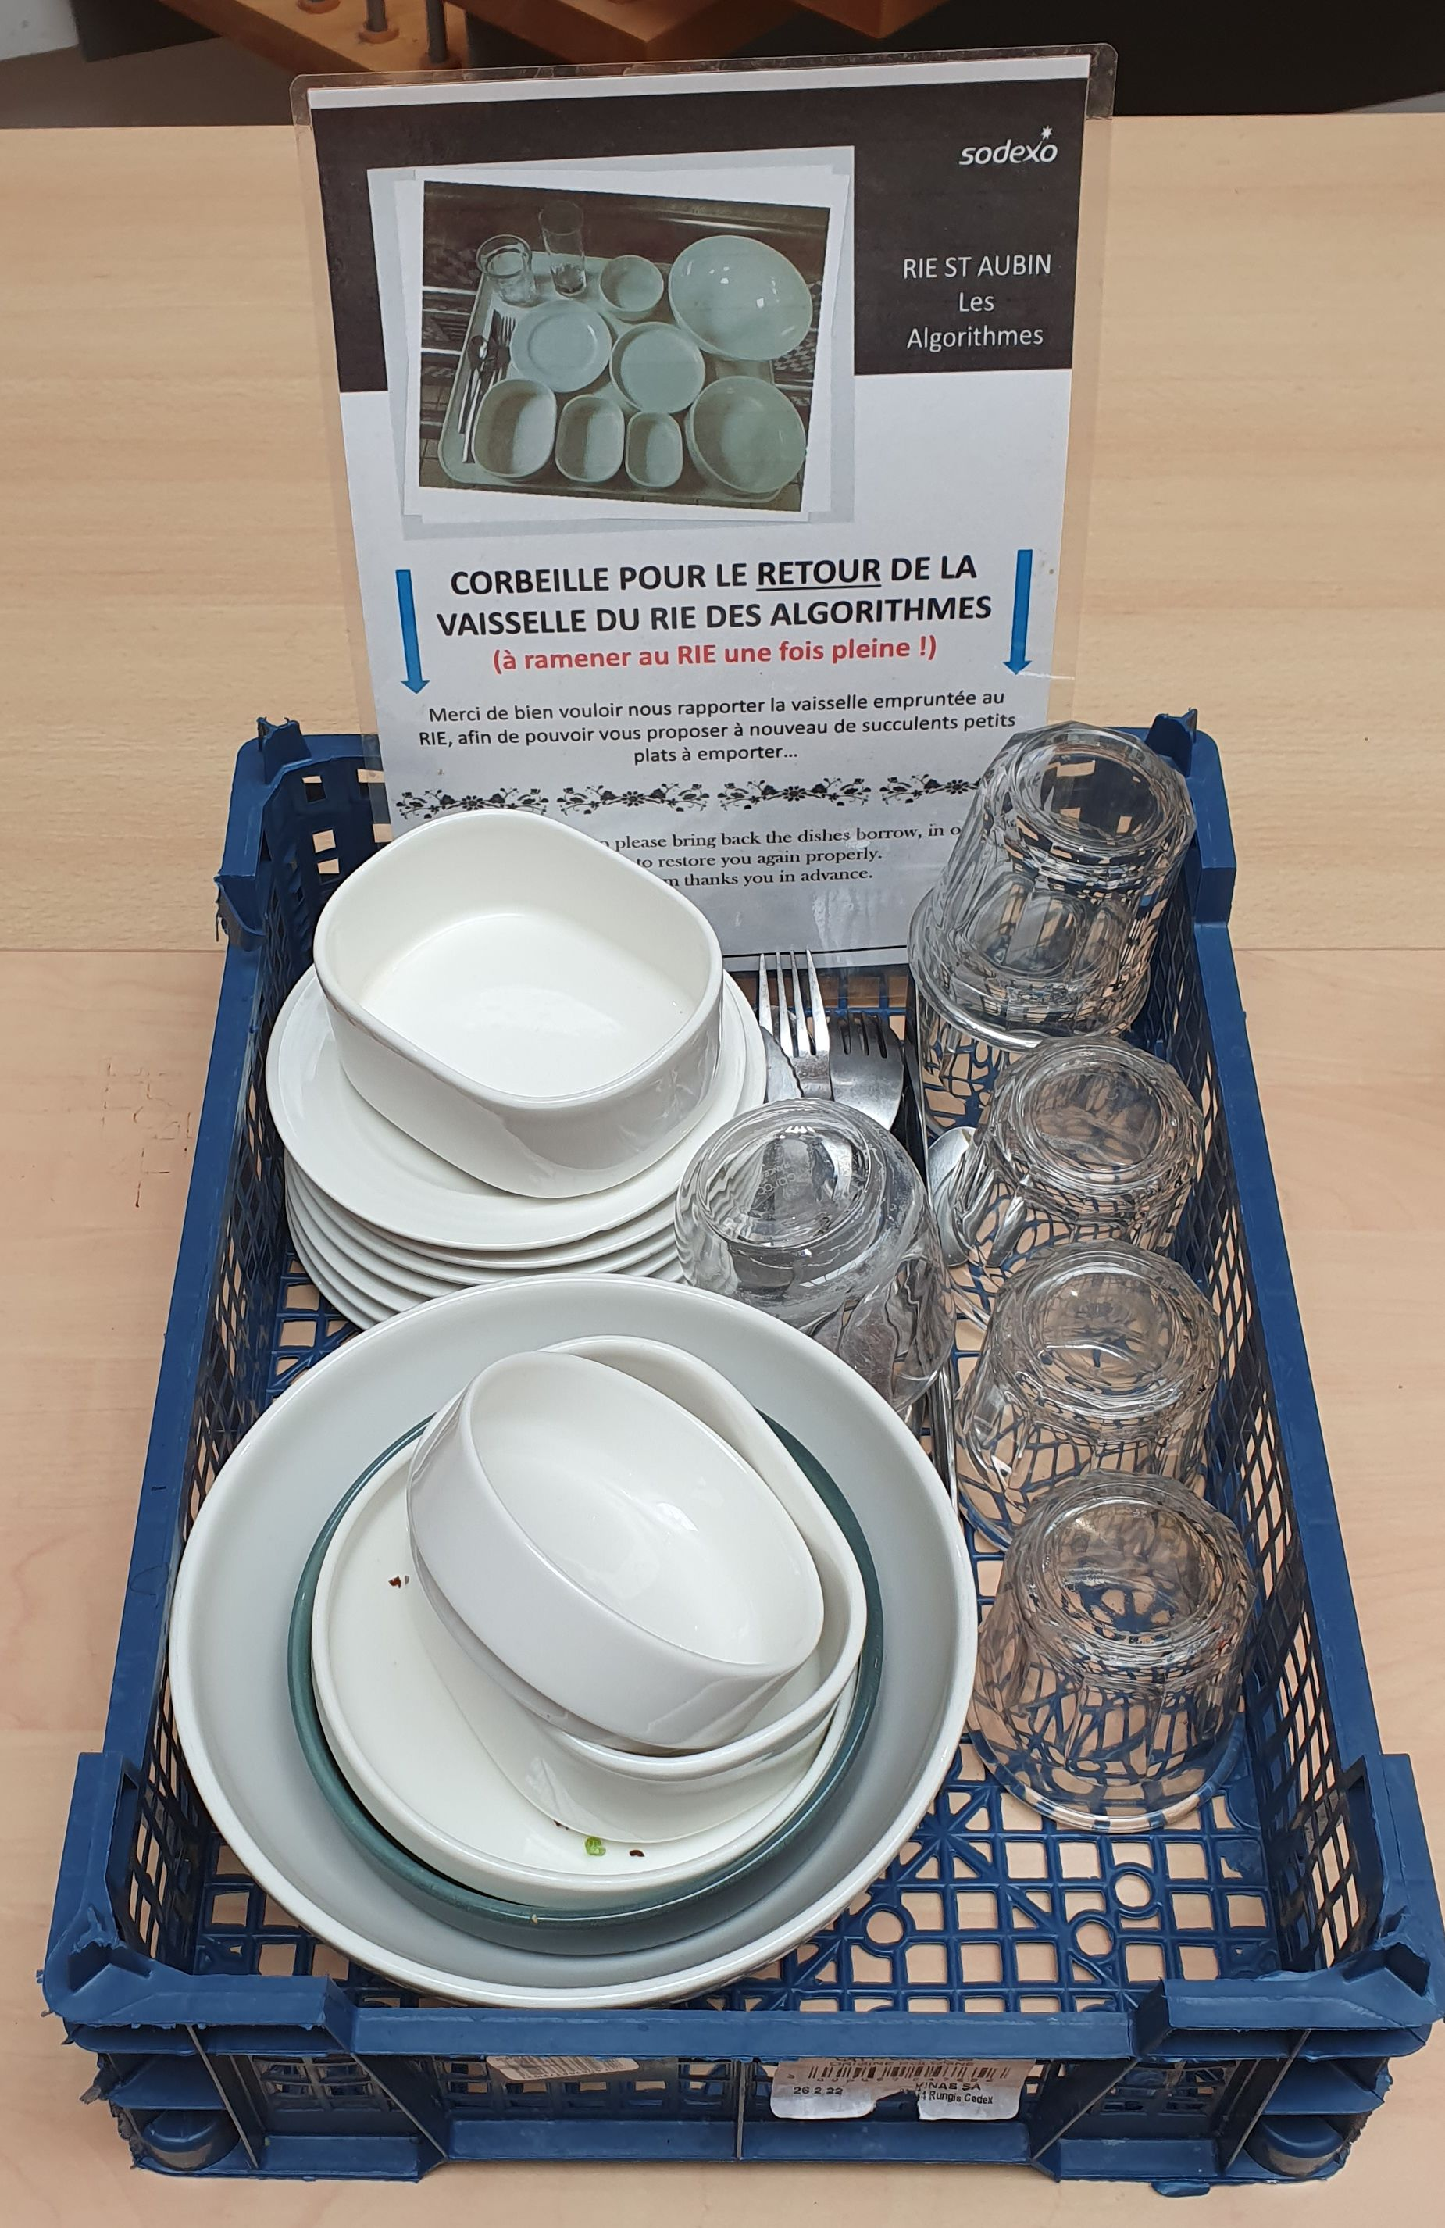
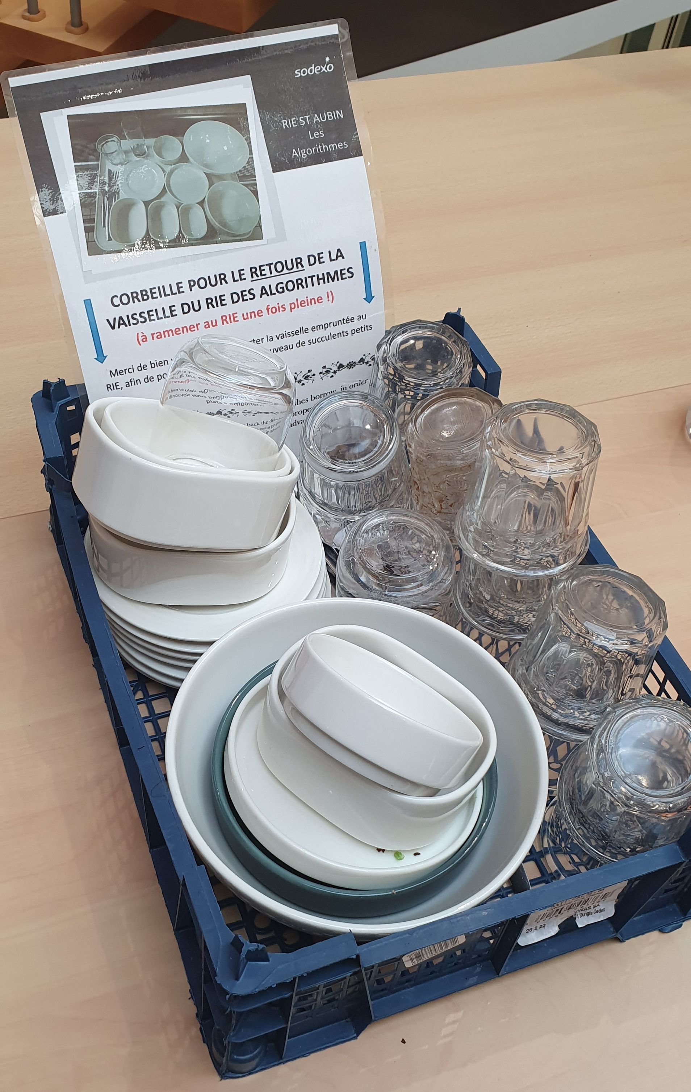
      - A bad example: these pictures were taken in September 2024, 1 week apart

Threshold warning examples

Mail warning example
When you get below the specified threshold, you will get a warning mail like this the next morning (no mail sen during the weekend)
Subject: Rechargement de votre badge
Date: Mon, 3 Apr 2023 08:29:34 +0200 (CEST)
From: sohappy <no-reply.so-happy@sodexo.com>
To: your_e-mail
SoHappy
Refill your badge
Hi,
Your badge balance dropped down below the limit you defined.
To refill, you simply have to click on the button below:
BADGE REFILLING <https://www.so-happy.fr/>
To stop notification, you can deactivate this function in the Badge/Limit Management section.
The SoHappy team

Phone app warning example
When you get below the specified threshold, you will get the following kind of notification on your phone, if you have installed the SoHappy app.
You can very easily refill your account, directly from the app, without having to specify your credit card information, if you have previously refilled your account.
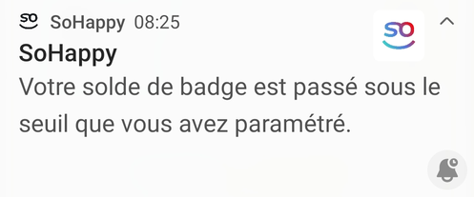

Menu and contact
- Menu: available on the So-Happy web site and app
- Contact information: ask JYP

Smartphone apps
You can use the SoHappy app to get the same information (and change settings) as with the web site
- Google Play
- App Store

[ PMIP3 Wiki Home ] - [ Help! ] - [ Wiki syntax ]

