Getting started in CLIM & ESTIMR
Welcome to the CLIM & ESTIMR teams!
You are probably reading this page because you are a new intern student, visitor, etc…
This page will help you survive your first steps at LSCE, at least survive the computers…
Reading this page will save your life (and a lot of time)!

Miscellaneous information
A few useful links that have nothing to do with science and software resources!
- Adding money online to your restaurant account
- Survival kit and other information for CDD and interns (LSCE intranet)

The LSCE mailing lists
It is important to join the correct mailing lists, if you want to get all the information you need, on time.

The 'all' list
When your account is created, your email address should automatically be added to the the all list, that can be used to send mails to all the people working at LSCE. You will also get IPSL information through this list
all@lsce.ipsl.fr | Everybody at LSCE
lsce-orme@lsce.ipsl.fr | People working at Orme
lsce-gif@lsce.ipsl.fr | People working in Gif
Mails sent to these lists will reach lots of people. Think well before sending a mail to these lists!

The 'clim' and 'estimr' lists
Ask your team leader or Jean-Yves to add you to your team's mailing list
List | Team | Archive
clim@lists.lsce.ipsl.fr | clim | https://lists.lsce.ipsl.fr/sympa/arc/clim
estimr@lists.lsce.ipsl.fr | estimr | https://lists.lsce.ipsl.fr/sympa/arc/estimr

Notes
- You have to be identified on the server to access most lists's details. Enter you login and email password in the email address and pasword fields at the top right of any mailing list web page
- You may want/need to join other mailing lists (project specific, sports, …). Check the list of lists to find about all the existing lists
- It is possible to use mails to interact with the LSCE lists server, rather than the web interface

Using your own computer at LSCE?
No need to try to connect your laptop to the LSCE wire network, it will not work!
The best you can do is use the eduroam or guest wifi network, if your office is close enough to one of the access points.
Warning! You can't connect directly to the obelix LSCE servers from the wifi network. You first have to connect to ssh1.lsce.ipsl.fr, and then to obelix

Accessing the LSCE intranet
Web site: https://intranet.lsce.ipsl.fr/
There is a lot of information available on the LSCE intranet, but you can only access it from a computer connected to the LSCE network
Everything about the LSCE servers (and other software and hardware information): https://intranet.lsce.ipsl.fr/informatique/en/orme/index.php
- Reading the mails with the webmail or Thunderbird
  - As soon as you have a LSCE e-mail address, make sure it is added to the clim or estimr mailing list
- Printers

Accessing the CEA Saclay intranet and other CEA web sites with vpnssl
It used to be possible to access the CEA Saclay intranet by just clicking on http://www-saclay.cea.fr/ from any computer on the LSCE network.
This is not possible anymore, now that LSCE is on the Paris-Saclay network (and not on the CEA network)
Use the following steps:
- Start Chrome (or try another browser)
- Open the following link: https://vpnssl.cea.fr/
  - ignore the security errors
  - this link will work from the Paris Saclay network, and ANY other location (e.g. home) OUTSIDE of CEA
- Use your initials and badge number as the login (e.g. “James Bond” ⇒ “jb007007”) and the number supplied by the activIDentity keyring, followed by your 4 digits personal code, as your password
- Select the CEA web site you want from the “Aventail WorkPlace” portal
  - Espace Sigma: that's where you specify when you will be on holidays
  - Intranet Saclay: where you can get information about the CEA buses, CEA directory, security training registration and information, practical information, etc…
  - Intranet du voyageur: if you need to make a plane/train reservation
  - …
- Click on logout when you are done

Setting up your desktop computer
Everybody working for CLIM & ESTIMR gets a computer that can be connected to the LSCE network. Please take the time to read the instructions below, that may help make your life easier

Windows 7 computer
Read the notes (and follow the instructions) in Windows 7 notes, especially the Basic Windows 7 Configuration section

Getting administrator's rights
Make sure you know what you are doing and that you are not executing a virus asking you suspicious access rights!
If an application requests administrator's rights to install something or make changes to the computer, and you are sure it's not a virus, use the .\adminuser account and the adminuser password you got when your computer was configured, or ask the system administrators.

Linux computer
There are different window managers available, each one with different settings: you should the Cinnamon window manager (xfce is a bit too basic, and Gnome is not very convenient for doing actual work, and uses too much CPU). You can select the window manager by clicking on the little cogwheel below the password field, on the login screen.
This is Linux, you are using it for work, you should be efficient, so you should be able to do most of your work by typing commands in a terminal. The true power is in the correct use of the command-line interfaces, rather than having to spend time finding where to click in the windows. You will find some Linux documentation below.

Using the root acount
Do not use the root account or privileges if you don't know exactly what you are doing!
Depending on what you need to do:
- run a single command with the root access rights
sudo command
- become root in a terminal
sudo su -
- use the root password when a program asks for it. Be sure the programs have legitimate reasons to ask for the root password!

Mac
Sorry, you are on your own, but it's soooo easy to use, right?

Accessing the Windows cluster from a Linux computer
Follow the instructions in the Windows servers page. If you need to use a program that is missing on this cluster, see the Help section

Accessing the Linux servers from your LSCE deskop

Linux or mac desktop
Just open a terminal and use ssh to connect to the appropriate server

Windows desktop
There should be an Obelix shortcut on the left side of your desktop. Double-click on it in order to open a window (e.g. with graphics) environment on one of the obelix servers. Each terminal you will open in this environment will run on the same obelix server. Use ssh to connect another server
If there is not yet an Obelix shortcut, use the VcXsrv XLaunch program to create it
Note: you can also use Putty if you just need text windows, or VcXsrv or Putty+Cygwin-X if you also need graphics

Which Linux servers should you use?
There are lots of things you can do directly on your local Win7 or Linux desktop (displaying pdf, images, using a text editor, …), rather than on the remote servers. Never forget that your local desktop has access to the remote disks on the Linux servers.
Otherwise, use the appropriate Linux servers. The load balancing system will send you to the server that has currently the smallest load
- obelixN (ssh obelix, or ssh obelix.lb): never forget that you are sharing these servers with other users! Do not use too much CPU and memory for a long time. Heavy computation should be done on the obelix cluster
- the batch system (aka obelix cluster) for really heavy duty programs
- in some cases, you may need an account to use the IPSL/ESPRI clusters (aka ciclad and climserv), especially if you need to use data that is already available/mirrored there, rather than copying the data to LSCE
- asterixN: some people may mention these servers, but they don't exist any more!

Which shell are you using?
It is important to know which shell you are using if you need to configure and tune your Linux account. The shell is basically the program that waits for you to type commands in a terminal and passes them to the computer
If you are not sure which shell is running in your terminals, you can use echo $SHELL to find out:
# Somewhere with tcsh
> echo $SHELL
/bin/tcsh
# Somewhere else with bash
$ echo $SHELL
/bin/bash

Determining the load of a Linux server
If the Linux server you are working on seems slow, or if you want to get an idea of the resources you are using, you should use the top command
jypeter@obelix4 - ...jypeter - 46 >top
top - 17:48:51 up 8 days, 23:43, 29 users, load average: 1.22, 1.38, 1.98
Tasks: 324 total, 2 running, 320 sleeping, 2 stopped, 0 zombie
Cpu(s): 12.6%us, 0.0%sy, 0.0%ni, 87.4%id, 0.0%wa, 0.0%hi, 0.0%si, 0.0%st
Mem: 32877756k total, 14706188k used, 18171568k free, 21372k buffers
Swap: 33554428k total, 1628972k used, 31925456k free, 14105940k cached
PID USER PR NI VIRT RES SHR S %CPU %MEM TIME+ COMMAND
10193 mpeau 20 0 302m 4336 2272 R 100.0 0.0 7033:08 emacs
16504 mpeau 20 0 110m 2008 1228 S 0.7 0.0 0:00.13 tcsh
26344 dzhu 20 0 1635m 20m 3880 S 0.3 0.1 0:44.90 ipython
1 root 20 0 21448 1108 892 S 0.0 0.0 0:01.61 init
[...]
The top lines give you some summary information about the system, but you should monitor the memory usage (VIRT and RES), CPU and TIME columns. By default, top will will put the processes using the more CPU at the top (as shown above). You can see above that the emacs text editor has clearly crashed, because it should not use 100% CPU for such a long time
If you type M, the processes will be sorted my memory usage, as shown below
PID USER PR NI VIRT RES SHR S %CPU %MEM TIME+ COMMAND
16092 jchang 20 0 8488m 8.1g 7912 R 99.6 25.9 1:41.38 idl
23256 pvait 20 0 232m 70m 2632 S 0.0 0.2 0:01.36 R
26344 dzhu 20 0 1635m 20m 3880 S 0.0 0.1 0:44.87 ipython
10619 astege 20 0 954m 9292 2664 S 0.0 0.0 0:40.67 gedit
1362 nslcd 20 0 442m 6056 2208 S 0.0 0.0 2:13.98 nslcd
16238 twang 20 0 128m 5068 2076 S 0.0 0.0 0:00.05 gconfd-2
10193 mpeau 20 0 302m 4336 2272 R 99.9 0.0 7024:13 emacs
[...]
Other useful keys:
q | Quit
c | Display the command line options of the running processes
u | List only the processes of a specific user

Which disks should you use?
- It is very important to use the correct directories and make it easy for your advisor to find things after you have left
  - Put the source codes, scripts and papers you are writing on a backed up disk
  - Put temporary files on a scratch disk
  - Do NOT put (big) data files on a backed up disk
- Do not forget to clean your directories before you leave (ask your advisor what should be kept or cleaned)

Accessing remote disks
It is possible to access directly all the disks on the LSCE servers from your local Linux or Windows desktop
- Example path on the LSCE Linux server: /home/scratch01/your_lsce_login
- Accessing the same path from a local desktop:
  - Linux desktop: /home/scratch01/your_lsce_login
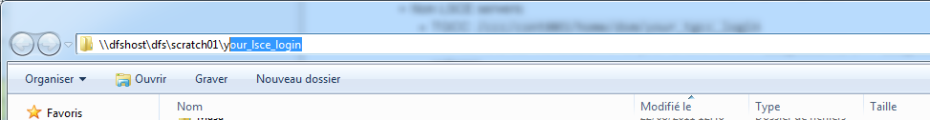
  - Windows desktop: \\dfshost\dfs\scratch01\your_lsce_login

The home directory
- Location: the location depends on the machine you are connected to in the current terminal
  - On the LSCE servers (obelixN): /home/users/your_lsce_login
    - Non LSCE servers:
      - TGCC: /ccc/cont003/home/dsm/your_tgcc_login
You can find out the location of all your directories with ccc_home -a (use ccc_home -h to find out all the available options)
      - ciclad: /home/your_ciclad_login
  - On a local Linux desktop (lsceNNNN): /homel/your_lsce_login
  - The configuration files of your Linux account are stored in the home directory (use ls -a to see hidden files and directories). Ask your advisor if you should copy somebody else's configuration files
    - tcsh shell users: .cshrc and .login
    - bash shell users: .profile and .bashrc
    - emacs text editor: .emacs
- Backup of the home directory on the LSCE servers: YES! Every night
  - More details on the backup system page
  - Put the most important sources/scripts/data/papers in this directory
  - Do not put temporary files, or big data files that are available somewhere else in this directory!
  - Your home directory will also be archived when your account is closed
- Backup of the TGCC home directory: YES!
  - Use the following command to access the backup: cd ~/.snapshot
- Quota: YES!
There is a limit to what you can store in your home directory. If you reach this limit, you may experience some seemingly random errors (can't connect to the servers, the new files have a 0 size, …)
The example below shows how to determine the quota on the LSCE disks: you can never go above the size displayed in the limit column, and you cannot stay more than 7 days above the limit displayed in the quota column! The grace column will display either None (you cannot write on the disk anymore, unless you get below the quota limit) or N days (you can use the disk, but you have N days to go below the quota limit)
> quota -s
Disk quotas for user jypeter (uid 6369):
Filesystem blocks quota limit grace files quota limit grace
prolix3:/users/ 4658M 4883M 4981M 23503 0 0

The scratch directory
- Location: /home/scratch01/your_lsce_login
- Backup: NO
  - Use this directory for temporary and big data files
  - The files older than 6 months (and possibly older than 1 month) will be automatically deleted if there is not enough free space. See the Scratch area section for more details on the retention policy
    - In other words, the files are guaranteed to stay 1 month and possibly longer
- Quota: NO

Project specific directories
- Location: /home/some_project_name/your_lsce_login
  - Ask your advisor if you should use a specific project directory and the technical details about it
  - Use this directory for storing the (big) data files that you can't store safely in the scratch directory, and should not store in the scratch directory
- Backup: ask your advisor
- Quota: ask your advisor

Determining the space used by directories
Your Linux environment may sometimes stop working correctly because you have exceeded the allowed quota on your disks (check your quotas with quota -s). You can use the following command to get the size of all the directories and files in the current directory, sorted by size: du -sh * | sort -rh
jypeter@obelix4 - ...jypeter - 46 >cd /home/scratch01/jypeter
/home/scratch01/jypeter
jypeter@obelix4 - ...jypeter - 47 >du -sh * | sort -rh
58M GLAC1DHiceF26.nc
47M dashboard
44M GLAC1DdrainagePointerF26ka.nc
15M octcdf
12M 1901.nc
3.2M cmake
...

Useful documentation for beginners

Linux/UNIX
- UNIX_doc_JYP.pdf: some basic Linux documentation. Make sure you read it!
  - A list of the most useful commands
  - A tutorial
- Useful Linux commands for working with (potentially big) text files (houchesa4_updated.pdf)
- Using ssh on Linux and Windows
- An annotated reference card of the emacs text editor (emacs_jyp.pdf)
  - JYP's .emacs file: for Linux - for Windows, with emacs for Windows
You can also check the Les fondamentaux du pôle de modélisation du climat de l'IPSL wiki page

NetCDF and file formats
- What are binary (binaire_jyp.pdf) and NetCDF (netcdf_jyp.pdf) files?
  - Network Common Data Form (NetCDF) official page
    - The different netCDF formats (and do not forget to use ncdump -k data.nc if you need to know the format)
- The NetCDF file format is self-documented, and the metadata of climate data files often follows the CF (Climate and Forecast) Metadata Conventions
  - The files in the CMIPn (n ≥ 5) database are written with the CMOR 3 library in order to make sure that they follow exactly the requested standards
- You can use Panoply and ncview for visualizing quickly the NetCDF files
- Climate Data Operators for manipulating NetCDF files (and some other formats)
- netCDF Operator (NCO) for manipulating NetCDF files
- NetCDF CF (Climate and Forecast) Metadata Conventions: this will help you understand the information you get when you do a ncdump -h some_climate_data_file.nc
- Using Python to work with NetCDF data:
  - Using the cdms2 module if you work with the UV-CDAT distribution
  - Using the netCDF4 module

Using the Python language
- Working with Python
- JYP's recommended steps for learning python

Getting help (from the LSCE system administrators)
Send a mail to: help-lsce@lsce.ipsl.fr

Describing your problem
When you need help from the administrators or other people, it will save a lot of time if you describe your problem as accurately as possible (do not just report XXXXX is not working as expected !)
You can copy-paste the error message(s). Finding the error log file(s) of the program/system (when available), or using the verbose mode of a program will make the problem resolution much easier and faster. The example below shows how to use the verbose mode of ssh
>ssh -v obelix
OpenSSH_7.4p1, OpenSSL 1.0.2k-fips 26 Jan 2017
debug1: Reading configuration data /home/users/jypeter/.ssh/config
debug1: Reading configuration data /etc/ssh/ssh_config
debug1: /etc/ssh/ssh_config line 58: Applying options for *
debug1: Connecting to obelix [157.136.72.75] port 22.
debug1: Connection established.
debug1: key_load_public: No such file or directory
debug1: identity file /home/users/jypeter/.ssh/id_rsa type -1
[...]
debug1: Entering interactive session.
debug1: pledge: exec
debug1: client_input_global_request: rtype hostkeys-00@openssh.com want_reply 0
debug1: Requesting X11 forwarding with authentication spoofing.
debug1: Sending environment.
debug1: Sending env LANG = en_US
Last login: Thu Mar 1 15:52:44 2018 from lsce4078.lsce.ipsl.fr
Disk quotas for user jypeter (uid 6369):
Filesystem space quota limit grace files quota limit grace
prolix3:/users 4558M 9766M 10743M 23741 0 0
jypeter@obelix3 - ...jypeter - 41 >

Taking a screenshot
Sometimes, it may also help to send a picture of what is wrong!
On Linux, you should find a screenshot application in the tools available on the system. See the example below for people using the xfce windows manager
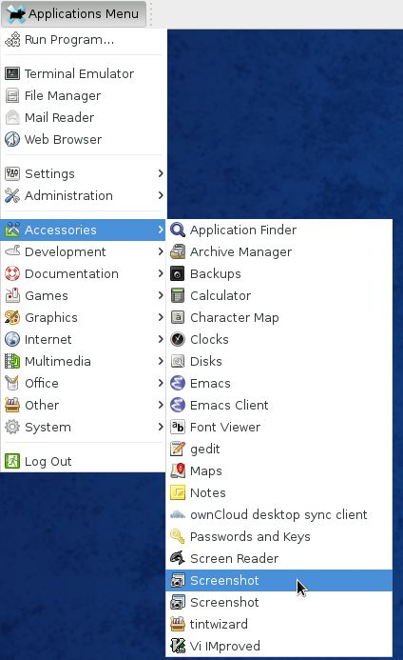Click to get a larger version
On Windows, you can use the Capture screen option of XnView
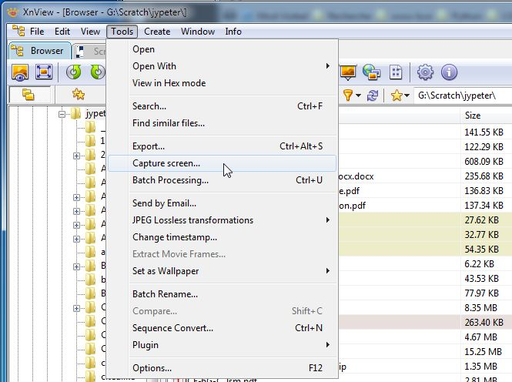Click to get a larger version

Accessing the LSCE servers from outside the LSCE
The only way to access the LSCE servers from outside LSCE is to connect first to the ssh1.lsce.ipsl.fr gateway server.

Interactive access
- Send a mail to help-lsce@lsce.ipsl.fr, and request an access to the ssh1 server
- Use ssh to connect to ssh1
  - From a Linux/mac desktop: ssh -A -X your_lsce_login@ssh1.lsce.ipsl.fr
  - From a Windows desktop:
    - Text only: use Putty
    - Text & graphics. This is more complex to set up, and you need to use one of the options below:
      - use VcXsrv
      - use cygwin/X
      - use VirtualBox
- You can access all LSCE disks from ssh1, but there is only a limited number of programs that you can run, so you have to go from ssh1 to obelix or curie with one of the ssh commands below:
  - ssh obelix
  - ssh your_tgcc_login@curie-ccrt.ccc.cea.fr
- It's possible to use only one line to to both ssh commands
  - obelix: ssh -A -X your_lsce_login@ssh1.lsce.ipsl.fr -t ssh -A obelix
  - TGCC: ssh -A -X your_lsce_login@ssh1.lsce.ipsl.fr -t ssh -A your_tgcc_login@curie-ccrt.ccc.cea.fr
- You can define an alias in order to connect more easily to the machines:
  - tcsh users: add the following line to your ~/.cshrc configuration file
alias sobelix 'ssh -A -X your_lsce_login@ssh1.lsce.ipsl.fr -t ssh -A obelix'
  - bash users: add the following line to your ~/.bashrc configuration file
alias sobelix='ssh -A -X your_lsce_login@ssh1.lsce.ipsl.fr -t ssh -A obelix'
- You should create and configure an ssh key, if you don't want to type your password each time you use ssh or scp
- If you want more information about ssh
  - Linux users: http://ciclad-web.ipsl.jussieu.fr/data/documents/ssh-utilisateurs-unix.pdf
  - Windows users: http://ciclad-web.ipsl.jussieu.fr/data/documents/ssh_putty_v2_2011-1.pdf

Copying files to/from LSCE
If you need to transfer files to/from LSCE, use scp (on Linux), or an scp client such as WinSCP (on Windows) between your computer and ssh1.lsce.ipsl.fr
- Example from a Linux/mac desktop: scp -p file_outside_lsce your_lsce_login@ssh1.lsce.ipsl.fr:/home/scratch01/your_lsce_login/

What next?
Ask you advisor, who has probably already told you everything that was listed above, so you did not really learn anything new by reading this page

[ PMIP3 Wiki Home ] - [ Help! ] - [ Wiki syntax ]

