Testing CLIMAF on ciclad
Reminder: JYP's CLIMAF installation notes
- Copy the notebooks:
  - cd somewhere/Notebooks
cp -pr /ciclad-home/jservon/TP_CliMAF .
- Initialize the python environment you want to use:
  - standard environment: module load climaf
  - JYP's environment: we assume that the required module load and environment variables have already been initialized from ~jypmce/.bashrc
    - conda activate cdatm_py2
- Start jupyter from the TP directory:
  - cd somewhere/Notebooks/TP_CliMAF
jupyter notebook --no-browser
    - You can also explicitly specify a port (e.g. use the one associated with your account in /ciclad-home/jservon/Evaluation/CliMAF/climaf_installs/climaf_1.2.10/bin/cmip6.notebook.txt) with
jupyter notebook --no-browser --port=pppp_number
  - Write down the connection URL and token: http://localhost:8888/?token=9f7682071ab5d6a3e…
    - The port number may be different from the default 8888
  - When you are finished, do not forget to kill the ipython server by typing ^C^C (2x CTRL-C)
- At LSCE (or on the Windows machine where you will run the browser connecting to the server on ciclad)
  - Use Putty to start a tunnel to the jupyter server on ciclad:
    - Create a New session (or update an existing one) with the following parameters
      - Host Name: ciclad.ipsl.jussieu.fr
      - Saved Sessions (the name used to save this set of parameters): your_login @ ciclad TUNNEL
      - Connection → Data → Auto-login username: your_login
      - Connection → SSH → Tunnels
        - Source port: 8000
        - Destination: localhost:8888 (or the port number displayed when you started the server on ciclad)
        - Click on Add and you should get something like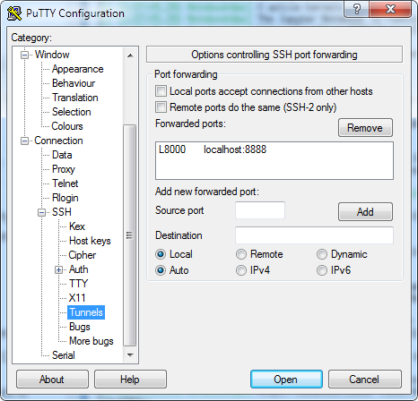
      - Click on Session (at the top left) and then Save
      - Click on Open. This will open a Putty terminal (with the tunnel) that you have to keep open as long as you need the tunnel, and remember to close at the end of your session
      - On your local machine, open the URL you got on the server, after having replaced 8888 (or whatever the port was) with 8000 (or whatever you chose as a Source port number above)
        - http://localhost:8000/?token=9f7682071ab5d6a3e…
- If you are on a Win10 machine with WSL, a Mac or a Linux machine, you can get the same result with:
  - Open a shell and type: ssh -L 8000:localhost:8888 your_login@ciclad.ipsl.jussieu.fr
  - In a browser, open the URL with the corrected 8000 port http://localhost:8000/?token=9f7682071ab5d6a3e…

Notes to clean
/ciclad-home/jservon/Evaluation/CliMAF/climaf_installs/climaf_1.2.10/bin/climaf-notebook
Login to ciclad
Start an interactive session on a cluster node: qsub -IVX -l mem=9g,vmem=9g,walltime=06:00:00
dig a tunnel from local machine to node: ssh -L 7225:cicladNNN:7225 jypmce@ciclad2.ipsl.jussieu.fr
init conda environment: conda activate cdatm_py2
start notebook: jupyter notebook --no-browser --port=7225 --ip=cicladNNN
(cdatm_py2) [jypmce@ciclad20 ~]$ jupyter notebook --no-browser --port=7225 --ip=ciclad20
[I 14:21:05.729 NotebookApp] [nb_conda_kernels] enabled, 5 kernels found
[I 14:21:06.344 NotebookApp] [nb_conda] enabled
[I 14:21:06.352 NotebookApp] Serving notebooks from local directory: /home/jypmce
[I 14:21:06.352 NotebookApp] The Jupyter Notebook is running at:
[I 14:21:06.352 NotebookApp] http://ciclad20:7225/?token=832aa384170471352b2a36444f610e54f2e16fde383a6741
[I 14:21:06.352 NotebookApp] Use Control-C to stop this server and shut down all kernels (twice to skip confirmation).
[C 14:21:06.365 NotebookApp]
To access the notebook, open this file in a browser:
file:///home/jypmce/.local/share/jupyter/runtime/nbserver-24895-open.html
Or copy and paste one of these URLs:
http://ciclad20:7225/?token=832aa384170471352b2a36444f610e54f2e16fde383a6741
open in local browser: http://localhost:7225/?token=832aa384170471352b2a36444f610e54f2e16fde383a6741

Issues to report
- handling of CLIMAF_LOG_DIR when it is set or not, esp last.out
- rename last.out ?
- problem with cfile when period is not set
- cdo not loaded with 'module load climaf'
- netcdf problems with some files on ciclad20

[ PMIP3 Wiki Home ] - [ Help! ] - [ Wiki syntax ]

