Installing extra applications for Windows 10
Other Windows 10 related notes

Misc notes
- You don't have to install all the applications mentioned of this page!
Just pick the ones you need
- The listed applications are not in alphabetical order. They are sometimes grouped by similar usage
- The applications will be installed by default on the C:\ disk. You may want to check the free space available on C:\ from time to time (remembering that you need enough space there for the system, system updates, what you store on your desktop, etc…)
  - Some installers will let you choose where you want to install the programs
  - Check Freeing up space and cleaning the computer if you need more space
- Some applications don't have a fancy installer, and just need to be extracted to a directory from a zip file (e.g Panoply, ImageJ). You should create a C:\Utils\ directory where you can put these applications
  - If you want to remove one of these applications, it should be OK to just remove its sub-directory from C:\Utils\
- Some applications can be installed directly from the Microsoft Store but you will have to download and execute the installer for most of the applications listed below
- You are probably running the 64bit version of Windows 10, so download the 64bit version of the installers, if there is a choice
- Getting the list of installed applications

Firefox and Thunderbird
- Thunderbird
- Firefox
Once you have installed FF and/or TB, you should follow the instructions for moving and restoring FF and TB. You should probably even read these before moving to a new computer, if you want to restore the FF and TB settings you had on the previous computer
- TB settings
- FF settings

Google Chrome
Install Chrome if you think that you may need an extra browser (besides the builtin Edge and the preinstalled Firefox) to test the content of some web pages or to use some videoconferencing software

Text editors

emacs
All the details on the Using the emacs text editor page

Notepad++
Notepad++ is a free source code editor and Notepad replacement that supports several languages
- It seems possible to work with remote files (with implicit sftp transfer) by using the NppFTP plugin
  - needs to be tested
  - does not seem as convenient as using emacs for working with remote files with the /user@server:/path/file syntax (but NPP is easier to install…)
  - support for ssh keys (i.e. the combination of a key file and a passphrase), but no support for ssh keys stored in pageant as of July 2022
- emacs is much more efficient than NPP for working with remote files

Image (bitmap) editors
The editors listed below go from the simplest to the most powerful (but harder to use)

Snip & Sketch
French : Outil Capture d'écran
For simple screenshots and/or annotating images, you can launch the preinstalled Snip & Sketch (Capture d'écran et croquis) tool from the Start menu
- Shortcut for taking a screenshot (and annotating it): Win + Shift + S
- You can only annotate (and save) the screenshot you have just taken. You can't open (and annotate) an existing image file

Sketchbook Pro
Autodesk SketchBook was bundled for free with Windows 10 till ~June 2021, and can now be bought from the Microsoft Store as Sketchbook Pro…
Sketchbook Pro can be used for freehand drawing (especially if you have a tablet or touch screen)

XnView Classic
JYP recommends using XnView Classic rather than MP, because of the very useful slideshow feature of the Classic version
XnView Classic is an efficient image viewer, browser and converter for Windows. This software is really simple to use and totally free for personal use. It supports more than 500 image formats
Download page (the Standard installer should be enough)

Paint.net
Paint.NET is an image and photo editing software for PCs that run Windows. It features an intuitive and innovative user interface with support for layers, unlimited undo, special effects, and a wide variety of useful and powerful tools.
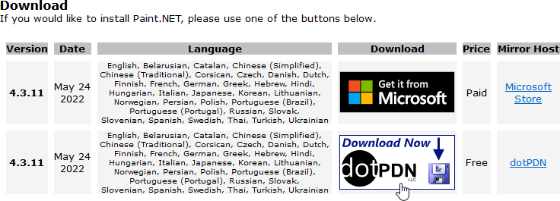
- You can either download Paint.net for free (and choose to make a donation), or buy it from the Windows 10 store (the payment is the donation)
Make sure you download paint.net by clicking on the correct download button, and not on one of the advertisement links!

ImageJ
ImageJ is a public domain Java image processing program, that may have some features not available in the other bitmap editors

Suggested installation steps
- Install Java SE Development Kit if it is not already installed
- Download the Platform Independent ZIP archive
- Create a C:\Utils directory (if it does not exist yet), and extract the ImageJ directory there
- Execute ImageJ.exe
ImageJ probably won't be able to locate the Java executable by itself, so navigate to the C:\Program Files\Java\jdk-17.0.4\bin\ directory and select the javaw.exe executable
  - Remove the ImageJ\ImageJ.cfg configuration file if you update Java later, or if you need to reset the ImageJ configuration

GIMP
GIMP is a cross-platform image editor available for GNU/Linux, macOS, Windows and more operating systems. It is free software, you can change its source code and distribute your changes.
Whether you are a graphic designer, photographer, illustrator, or scientist, GIMP provides you with sophisticated tools to get your job done. You can further enhance your productivity with GIMP thanks to many customization options and 3rd party plugins
- Get this powerful image editor only if you need a free replacement of Adobe Photoshop and you have time to read tutorials!
The image editors listed above (especially XnView) should be enough for your needs

Image (vector) editors

Inkscape
Inkscape is a Free and open source vector graphics editor for GNU/Linux, Windows and macOS.
It offers a rich set of features and is widely used for both artistic and technical illustrations such as cartoons, clip art, logos, typography, diagramming and flowcharting. It uses vector graphics to allow for sharp printouts and renderings at unlimited resolution and is not bound to a fixed number of pixels like raster graphics.
- Inkscape can theoretically be used as a replacement for Adobe Illustrator
- SVG (not ps/pdf) is the native format of Inkscape. If you know that you may have to alter/update a vector image later (using Inkscape), you may want to save it in .svg format as well as .pdf, when possible.

Other media

VLC media player
VLC VLC is a free and open source cross-platform multimedia player and framework that plays most multimedia files as well as DVDs, Audio CDs, VCDs, and various streaming protocols.

Data visualization
The following applications allow you to visualize NetCDF files without using a programming language (and probably more). You can of course also use Python

Panoply
NASA GISS Panoply plots geo-referenced and other arrays from netCDF, HDF, GRIB, and other datasets. Panoply is a cross-platform application that runs on Macintosh, Windows, Linux and other desktop computers.

Suggested installation steps
- Install Java SE Development Kit if it is not already installed
- Download the latest Panoply zip file for Windows
- Create a C:\Utils directory (if it does not exist yet), and extract the PanoplyWin-version directory there
- Execute Panoply.exe and try to open an existing NetCDF file

Vapor
NCAR Vapor is the Visualization and Analysis Platform for Ocean, Atmosphere, and Solar Researchers. It provides an interactive 3D visualization environment that can produce animations and still frame images, and runs on Windows, OSX, Ubuntu, and CentOS.

Paraview
ParaView is an open-source, multi-platform data analysis and visualization application.
ParaView users can quickly build visualizations to analyze their data using qualitative and quantitative techniques. The data exploration can be done interactively in 3D or programmatically using ParaView’s batch processing capabilities.

Retired Software
- IBM OpenDX (the open source successor of IBM Data Explorer) is dead

Backup software
You probably think that just copying a folder from time to time with a drag 'n drop is enough, but this becomes difficult to manage when the folder size grows and you have several folders to manage
There are several types of backup (mirror, incremental or differential imaging, cloning, 2 way synchronization, etc…) of different sources (full disks, partitions, directories, …) to/from different destinations (external disk, cloud, …)
Our basic need is to mirror one source directory on a local disk to a destination directory on an external disk (check the users' manuals if you need more features). This can be easily done with SyncBack
A short definition of mirroring:
- Copy all the files of the source to the destination. All the files are copied on the first run, only the new/changed files are copied on subsequent runs.
- Warning! if a file is not on the source anymore, mirroring will automatically remove it from the destination! The idea is that the destination should be an exact copy of the source! If that's not what you want, check the backup (rather than mirror) options.
Note: List of backup software (wikipedia)

ownCloud
- ownCloud (combined with LSCE sharebox) is very useful and you should read the dedicated page!
- ownCloud can be used on Windows, Linux and Mac!
ownCloud Desktop Client enables you to connect folders on your desktop to your corporate ownCloud Server. With it you can create folders, organize your local ownCloud directory, and keep the contents of your local directory synced with your ownCloud server. Anything shared with you will also appear in your home directory on your desktop, and changes will be automatically synced.
ownCloud is compatible with:
- the CNRS "mycore" cloud
- the LSCE "sharebox" cloud

SyncBack
You can use the SyncBack family of products to backup, synchronize, and restore data files.
The SyncBackFree version should be enough for easily mirroring directories, or groups of directory to an external disk, but you can compare the features available in SyncBackPro, SyncBackSE and SyncBackFree: summary comparison and full comparison.
It is very important to backup your work regularly. Check the Using SyncBack page for more details.

Macrium Reflect
Note: JYP has not really tested the Macrium option…
Macrium Reflect is image based backup and cloning software. Macrium Reflect creates an accurate and reliable image of a hard disk or the partitions on the disk. In the event of a partial or complete system loss, you can use this image to restore the entire disk, one or more partitions, or even individual files and folders.
The Free Edition can be used for imaging or cloning a full disk
- Check the Product Comparison to determine the available features
- Tutorial on Windows Central

rsync (Linux !)
rsync is a convenient Linux command that can be used for mirroring a directory hierarchy to another location on the same computer (e.g. a removable disk) or a remote server. It can also be used on a Windows 10 computer where WSL + Ubuntu is installed!
On Windows, it is easier to use the mirroring option of SyncBack.
Read the Mirroring directories with rsync on the ssh page

Conferencing software

Zoom

Installation
- Microsoft Store
- Zoom web site

Configuration
Sign in with SSO and cnrs.zoom.us if you have CNRS credentials

Terminals

Windows cmd command interpreter
There is nothing to install, cmd is the basic Windows command interpreter
- Starting: you can just type cmd+Enter in the Windows search field (or use another way)
- Several ways to Copy/Paste text:
  - Right-click on the cmd windows bar:
    - Change⇒Copy or Paste
    - Properties⇒Options to check the options, including the useful QuickEdit mode and Use Ctrl+Shift+C/V as Copy/Paste option mentioned below
  - Follow the steps in Copy and Paste arrives for Linux/WSL Consoles and you will then be able to copy/paste by using Shift+Ctrl+C/V
  - The QuickEdit mode should already be selected by default and you can also:
    - select text with the left mouse button
    - paste the selected text with the right mouse button (click twice after a new selection)
- Misc:
  - Use Alt+Enter to toggle the terminal to full screen
  - More shortcuts

Windows PowerShell
There is nothing to install, the PowerShell is directly available in Windows
- Starting: right-click on the Windows icon (or Win+X) and select Windows PowerShell
- Copy/pasting text: same as in a cmd interpreter
- Misc:
  - PowerShell documentation

Windows Terminal
Windows Terminal is a powerful and configurable interface that can be used to open Powershell,cmd and WSL windows
- After installation, the Terminal can be found in Start⇒Terminal
- Once installed, it is recommended to make Windows Terminal the default terminal application
  - Settings ⇒ Startup ⇒ Default terminal application
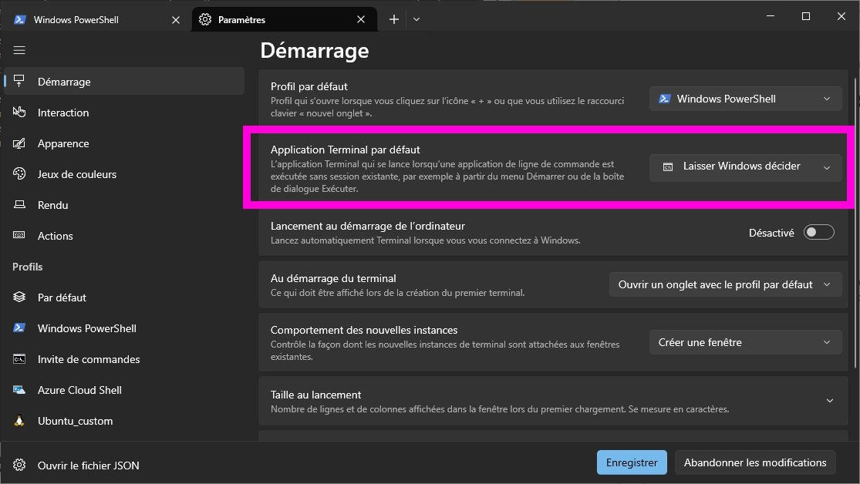
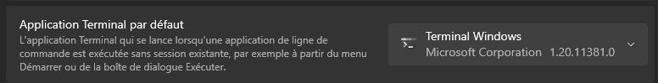
- When a Terminal is started, new terminals can be opened from the pull-down menu
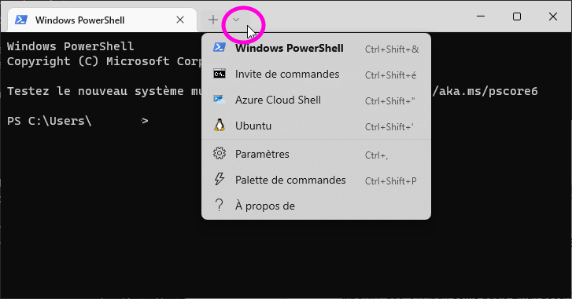
  - The Ubuntu terminal will appear only after installing WSL+Ubuntu
  - Hold the CTRL key when clicking on Windows PowerShell, if you need a PowerShell in admin mode
- Installing Windows Terminal will make the nice Cascadia Code font available on the system.
This font is most recommended to be used with terminal applications and text editors, and can be used in PuTTY and other applications that can benefit from a good monospaced font!
- Copy/pasting text: more or less the same as in a cmd interpreter
  - See also Selecting/Copying/Pasting text in Windows Terminal and the additional options you get when right-clicking on a Windows Terminal bar
- Terminal Documentation and GitHub page
  - See also Set up Windows Terminal in the WSL documentation
- The Terminal can also be used to open a local Linux terminal, when Windows Subsystem for Linux (WSL) is installed and configured
  - It will be possible to use the Windows Terminal as a replacement for PuTTY, once we can configure the mouse buttons to replicate selection/copy/paste (Feature request: add xterm-style select/copy/paste options)
- Windows Terminal development blog: new features appear in Windows Terminal Preview and are then included in the regular Windows Terminal

PuTTY & Pageant
PuTTY is a free implementation of SSH and Telnet for Windows and Unix platforms, along with an xterm terminal emulator.
In other words, PuTTY is an easy to use ssh client for Windows that will allow you to connect to the LSCE servers with a very efficient text terminal
If you are in a hurry and PuTTY is not installed yet, you can directly use the ssh provided with Windows 10!
- Right click on the Start menu and select Powershell, or use Start => Terminal
- Type ssh user@server
- It is still very useful to install PuTTY, because this will allow you to configure/save sessions, and then connect very easily to other computers later. You will also be able to do Linux-like copy-paste with your mouse!
- If you have installed WSL+Ubuntu on Windows 10, you can just open a terminal and type ssh user@server to connect to the server
Read the Installing and configuring PuTTY page to learn the best way to use PuTTY (and VcXsrv if you have to display remote graphical windows)
You should probably also have a look at the understanding and using ssh correctly page, if you want to understand basic ssh options, and how PuTTY and VcXsrv interact

Linux related tools

WinSCP
The latest versions of WinSCP will install some parts of PuTTY by default, which we don't want because we prefer to install PuTTY ourselves
If you have not installed PuTTY yet, do it before installing WinSCP
When the installer asks which Installation type you want, select the Custom Installation and unselect Pageant and PuTTYgen in the Components options screen
WinSCP is a popular SFTP client and FTP client for Microsoft Windows! Copy file between a local computer and remote servers using FTP, FTPS, SCP, SFTP, WebDAV or S3 file transfer protocols.
- WinSCP will automatically use the private ssh key stored in Pageant (installed with PuTTY) for authentication, if Pageant is running and configured properly
- You can use WinSCP to transfer files between your computer and ssh1 when you are outside LSCE.
  - When you are on the LSCE network, you should directly use local folders on the LSCE servers
- If you have installed WSL+Ubuntu, you can directly use scp from a terminal!

Windows X Server
Check the Using an X server on Windows section of the Installing and configuring an X server page. You should probably read the full page, or at least the table of content

Windows Subsystem for Linux (WSL)
Check the WSL page if you want to run Ubuntu (or another Linux) on your Win10 computer!!

Citation management tools

Overview
- Manage Citations with Zotero, Mendeley, and EndNote

Zotero
Zotero is a free, easy-to-use tool to help you collect, organize, cite, and share research
Zotero is a great tool but, for obvious security reasons, you should not store your data in the Zotero cloud (free or paying)
You can perfectly use Zotero without creating an account! More details below
- Download and install Zotero
  - You should avoid creating a Zotero account and synchronizing your research data to an unknown cloud!
Zotero will work perfectly without creating an account
- Download and install the Zotero Connector extension in the current browser (and possibly all the other browsers you regularly use)
  - Zotero Connectors automatically sense content as you browse the web and allow you to save it to Zotero with a single click
  - Note: Zotero must be running when you click on the connector button in your browser (but you will be reminded by a popup, if that's not the case)
- Start Zotero for the first time, and update some basic preferences (Edit ⇒ Preferences)
  - Language: Advanced ⇒ Language ⇒ English
  - Main Zotero folder:
    - This is the local folder where all of the Zotero data (except the settings) will be stored: database, documents (pdf, …)
      - Zotero only needs a local folder in order to work on a given computer. You do not need a Zotero cloud account
      - Default local folder location (on Windows): C:\Users\<your_login>\Zotero
      - Moving the local folder to a known location (preferably outside of the C:\ drive on Windows) will make it easier to create a backup of Zotero data (and restore/move the data to another computer), and synchronize Zotero data between computers without having to use a Zotero account
    - Recommended new locations for the local folder:
      - A sub-directory of your Local OWNCLOUD FOLDER, if you have configured LSCE sharebox and ownCloud
<some_disk_different_from_c>:\Users\<your_login>_owncloud\Zotero
        - If you use ownCloud+sharebox to synchronize Zotero data between different computers, you should have only one version of Zotero running, in order to avoid synchronization conflicts!
i.e. be sure to close Zotero on a computer before shutting down the computer and using Zotero on your other computer
      - Or a sub-directory of your Local HOME FOLDER
<some_disk_different_from_c>:\Users\<your_login>\Zotero
    - Change the Zotero local folder location in Advanced ⇒ Files and Folders ⇒ Data Directory Location:
      - Specify the new location (ideally one of the folders in the Recommended locations above) in the Custom field
      - Quit Zotero
      - Move data to the new location
        - New Zotero user: move the full content of the default Zotero folder (C:\Users\<your_login>\Zotero on Windows) to the new location
        - Existing user: move the existing Zotero content (coming from another computer or a backup) to the selected Custom location
      - Restart Zotero
    - More details in The Zotero Data Directory page
- Use Zotero to easily add bibliographies to your documents!
  - Supported word processors: Microsoft Word, LibreOffice, and Google Docs
    - If your favorite word processor is not supported, you can still copy a bibliography to the clipboard and paste it in a document
  - Zotero must be running when you use the plugin in the supported processors!
    - The word processor should display a warning popup if you have forgotten to start Zotero
- Follow the Zotero (gestion des références bibliographiques) (French) online training class

Publish or Perish
Publish or Perish is designed to help individual academics to present their case for research impact to its best advantage, even if you have very few citations

7-Zip
7-Zip is a file archiver with a high compression ratio
Supported formats:
- Packing / unpacking: 7z, XZ, BZIP2, GZIP, TAR, ZIP and WIM
- Unpacking only: AR, ARJ, CAB, CHM, CPIO, CramFS, DMG, EXT, FAT, GPT, HFS, IHEX, ISO, LZH, LZMA, MBR, MSI, NSIS, NTFS, QCOW2, RAR, RPM, SquashFS, UDF, UEFI, VDI, VHD, VMDK, WIM, XAR and Z.

Python
Depending on which kind of data you work with, you can install a local Python distribution:
- Directly in Windows
- Or in the WSL + Ubuntu virtual machine, if you have installed one on your Windows computer
Remember that it is always better to move the computation where the original (an possibly huge) data files are, and you should probably use a remote Python distribution (e.g. if your data is located at LSCE)

CDAT
CDAT is a Python distribution for the climate scientist. It can only be installed in the WSL+Ubuntu part of a Win10 computer. Check the installation instructions for 8.1 (or later)

Anaconda
This is the recommended (by JYP) Python distribution/environment. It is available for Windows, Mac and Linux
The Anaconda distribution is provided by the Anaconda company (that was previously called Continuum Analytics). It is similar to EDM, but probably more widely used than EDM
Note: Anaconda provides and uses conda for its installation. Since CDAT is also installed and maintained with conda, you can read the Installing and maintaining UV-CDAT with conda page for more information, even if you are not going to use CDAT

Enthought Deployment Manager (EDM)
This was previously called Enthought Python Distribution (EPD) and then Enthought Canopy
Enthought Deployment Manager (EDM) is Enthought’s mechanism to deliver scientific software applications and development environments
There are native installers for Windows (.msi), Mac OS X (.pkg), RHEL/Fedora (.rpm), and Debian/Ubuntu (.deb)

Java SE Development Kit (JDK)
You only need to install the JDK if other applications (e.g Panoply, ImageJ) need it
- There are many versions of Java
  - Determine which one is the latest LTS (Long Time Support) version of Java (e.g Java SE 21 in June 2025)
- Download the x64 Installer of the latest LTS (e.g. JDK Development Kit 21.0.7 in June 2025) for your computer and install it
  - For Windows, get the x64 MSI Installer and execute it

Some technical packages
There is a good chance you don't need these programs!

BlueScreenView
This utility makes it possible to display information about previous crashes of a Win computer. Use this if your PC has experienced a BSOD (Blue Screen of Death) and you want to know what happened
* Web & Download: http://www.nirsoft.net/utils/blue_screen_view.html

nmap / zenmap / nping
nmap for Windows can be installed when we need to install nping to check if a network connection is stable, instead of using the ping command directly available in Windows
- ping ssh1 every minutes (–delay 1m) during 1 hour (-c 60), without displaying the sent packets (-H)
  - nping –delay 1m -c 60 -H ssh1

More applications

Samsung phone users

Smart Switch
Samsung Smart Switch seamlessly transfers contacts, photos, music, videos, messages, notes, calendars and more to virtually any Samsung Galaxy device.
- Can be used for backing up your phone

TODO

Using Microsoft PowerToys
Check what could be useful in Microsoft PowerToys: Utilities to customize Windows

Using Dev Home
Check what could be useful in Dev Home

Using Visual Studio Code
Check what could be useful in Visual Studio Code

Installing applications with winget

winget documentation
- Windows Package Manager main documentation
- Use the winget tool to install and manage applications (a list of the available winget commands and their options)
- winget issues @ GitHub

Some quick upgrade examples
- XnView Classic: winget upgrade --id XnSoft.XnView.Classic
- WinSCP: winget upgrade --id WinSCP.WinSCP

winget 'problems'
- The sorting order of 'winget list' does not make sense
  - Workaround A: use winget list | sort
  - Workaround B:
    - Install extra PowerShell modules with
Install-Module Microsoft.WinGet.Client
Import-Module Microsoft.WinGet.Client
    - Get a sorted list with Get-WinGetPackage | sort name or Get-WinGetPackage | sort id

emacs example
More about winget+emacs in the Windows sections of the dedicated emacs page
PS C:\Users\your_login> winget search --name emacs
Nom ID Version Source
-----------------------------------
GNU Emacs GNU.Emacs 29.1 winget
PS C:\Users\your_login> winget show --id GNU.Emacs
Trouvé GNU Emacs [GNU.Emacs]
Version : 29.1
Publisher : GNU Project
ID de l’Editeur https://www.gnu.org
Moniker : emacs
Description : An extensible, customizable, free/libre text editor - and more.
Page d’accueil : https://www.gnu.org/software/emacs/
Licence : GPL
Copyright : Copyright (C) 2022 Free Software Foundation, Inc.
Mots-clés :
emacs
gnu
text-editor
tool
utility
Programme d'installation :
Type du programme d’installation : nullsoft
URL du programme d’installation : https://ftp.gnu.org/gnu/emacs/windows/emacs-29/emacs-29.1_2-installer.exe
SHA256 du programme d’installation : c6f43de2b51afc6dcdf1391708dcf1e2f3c4132b4cf9bb7de6611f2432bbcbf5
PS C:\Users\your_login> winget show --id GNU.Emacs --versions
Trouvé GNU Emacs [GNU.Emacs]
Version
-------
29.1
28.2
28.1
27.2
27.1
PS C:\Users\your_login> winget install --id GNU.Emacs
Trouvé GNU Emacs [GNU.Emacs] Version 28.2
La licence d’utilisation de cette application vous est octroyée par son propriétaire.
Microsoft n’est pas responsable des paquets tiers et n’accorde pas de licences à ceux-ci.
Downloading https://ftp.gnu.org/gnu/emacs/windows/emacs-28/emacs-28.2-installer.exe
██████████████████████████████ 46.2 MB / 46.2 MB
Le code de hachage de l’installation a été vérifié avec succès
Démarrage du package d’installation... Merci de patienter.
Installé correctement
PS C:\Users\your_login> winget list --id GNU.Emacs
Aucun package installé ne correspond aux critères saisis.

WinSCP example
PS C:\Users\your_login> winget list --id WinSCP.WinSCP
Nom ID Version Disponible Source
-----------------------------------------------------
WinSCP 5.21.5 WinSCP.WinSCP 5.21.5 5.21.6 winget
PS C:\Users\your_login> winget show --id WinSCP.WinSCP
Trouvé WinSCP [WinSCP.WinSCP]
Version : 5.21.6
PS C:\Users\your_login> winget upgrade
Nom ID Version Disponible Source
------------------------------------------------------------------------------------------------------------------------------------
[...]
Zotero DigitalScholar.Zotero 6.0.15 6.0.18 winget
WinSCP 5.21.5 WinSCP.WinSCP 5.21.5 5.21.6 winget
Microsoft Visual C++ 2013 Redistributable (x64) - 12.0.30501 Microsoft.VCRedist.2013.x64 12.0.30501.0 12.0.40664.0 winget
[...]
PS C:\Users\your_login> winget upgrade --id WinSCP.WinSCP
Trouvé WinSCP [WinSCP.WinSCP] Version 5.21.6
La licence d’utilisation de cette application vous est octroyée par son propriétaire.
Microsoft n’est pas responsable des paquets tiers et n’accorde pas de licences à ceux-ci.
Downloading https://sourceforge.net/projects/winscp/files/WinSCP/5.21.6/WinSCP-5.21.6-Setup.exe/download
██████████████████████████████ 10.9 MB / 10.9 MB
Le code de hachage de l’installation a été vérifié avec succès
Démarrage du package d’installation... Merci de patienter.
Installé correctement
PS C:\Users\your_login> winget list --id WinSCP.WinSCP
Nom ID Version Source
-------------------------------------------
WinSCP 5.21.6 WinSCP.WinSCP 5.21.6 winget

PuTTY example
There are several versions of PuTTY available, but you want to use the official version (maintained and free).
The official version is available with 2 different winget IDs:
- XPFNZKSKLBP7RJ for the version available directly from Microsoft Store. More details in Is the version of PuTTY in the Microsoft Store legit?
- PuTTY.PuTTY if you download an installer from the official PuTTY download page
PS C:\Users\> winget search putty
Nom ID Version Correspondance Source
-----------------------------------------------------------------------------------------------------------------
PuTTY XPFNZKSKLBP7RJ Unknown msstore
SSH & SFTP Client: Terminal, Telnet & Secure Putty 9PKGBV7S35T0 Unknown msstore
PuTTY PuTTY.PuTTY 0.81.0.0 winget
NETworkManager BornToBeRoot.NETworkManager 2024.6.15.0 Tag: putty winget
PortX NetSarangComputer.PortX 2.2.10 Tag: putty winget
PuTTY CAC NoMoreFood.PuTTY-CAC 0.81.0.0 Tag: putty winget
MTPuTTY TTYPlus.MTPutty 1.8 Tag: putty winget
SuperPuTTY JimRadford.SuperPuTTY 1.5.0 winget
PS C:\Users\> winget list --id XPFNZKSKLBP7RJ
Nom ID Version Disponible Source
----------------------------------------------------------------------
PuTTY release 0.77 (64-bit) XPFNZKSKLBP7RJ 0.77.0.0 0.80.0.0 msstore
PS C:\Users\> winget list --id PuTTY.PuTTY
Nom ID Version Source
--------------------------------------------------------
PuTTY release 0.81 (64-bit) PuTTY.PuTTY 0.81.0.0 winget
PS C:\Users\jypeter> winget upgrade --id XPFNZKSKLBP7RJ
Trouvé PuTTY [XPFNZKSKLBP7RJ] Version 0.80.0.0
[...]
L’éditeur exige que vous consultiez les informations ci-dessus et acceptiez les contrats avant de procéder à l’installation.
Acceptez-vous les conditions ?
[Y] Oui [N] Non: Y
Téléchargement en cours https://cdn.storeedgefd.dsx.mp.microsoft.com/wus2/cachedpackages/ee66263e-95da-4735-a5ff-6d154a347979_858399ee9ee49e15a78c7018dbf0dd73dba8337d6f0adb841896ba553c9a646c
██████████████████████████████ 3.53 MB / 3.53 MB
Le code de hachage de l’installation a été vérifié avec succès
Démarrage du package d’installation... Merci de patienter.
Installé correctement
PS C:\Users\jypeter> winget list --id XPFNZKSKLBP7RJ
Nom ID Version Source
------------------------------------------------------------
PuTTY release 0.80 (64-bit) XPFNZKSKLBP7RJ 0.80.0.0 msstore

