PMIP4-CMIP6 21k ice-sheet gallery
The plots on this page are 21k-0k orography difference plots, with orography set to 0 (zero) where there is no land (in the land-sea mask)
TODO list
- Add the Caspian sea to the land-sea mask

Cylindrical projection

PMIP3 blended ice-sheet
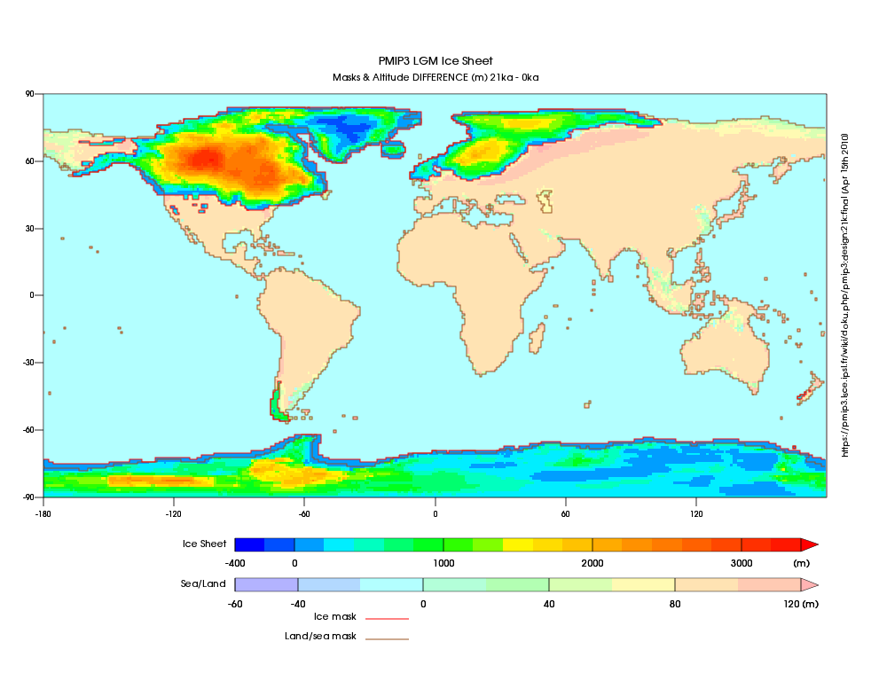 pdf version

Peltier ICE-6G-C for PMIP4
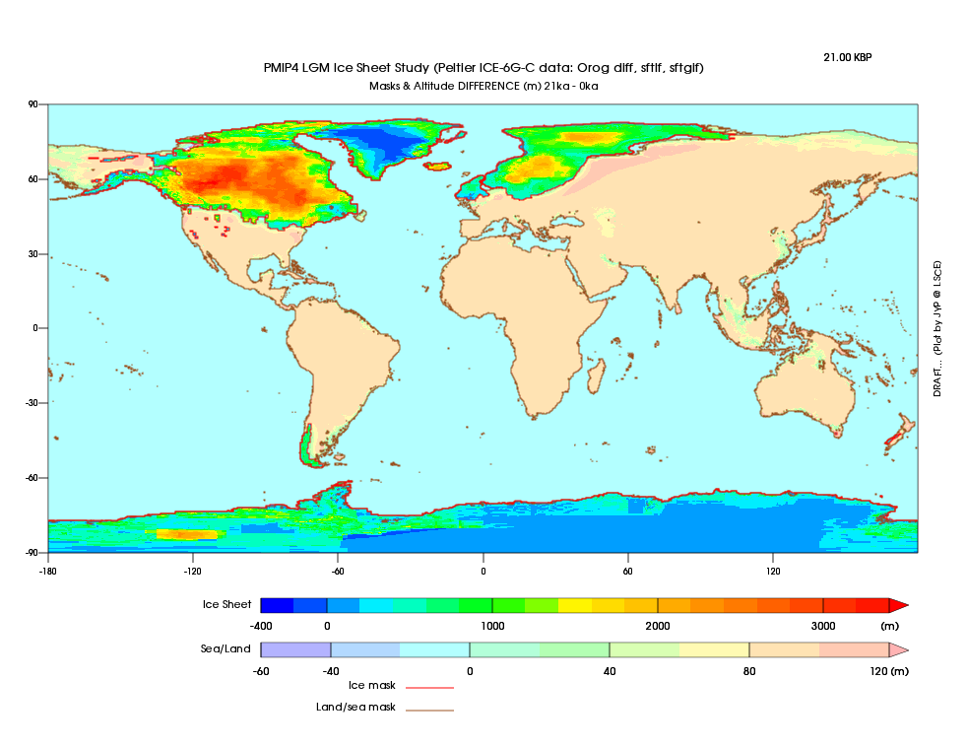 pdf version

Tarasov GLAC-1D for PMIP4
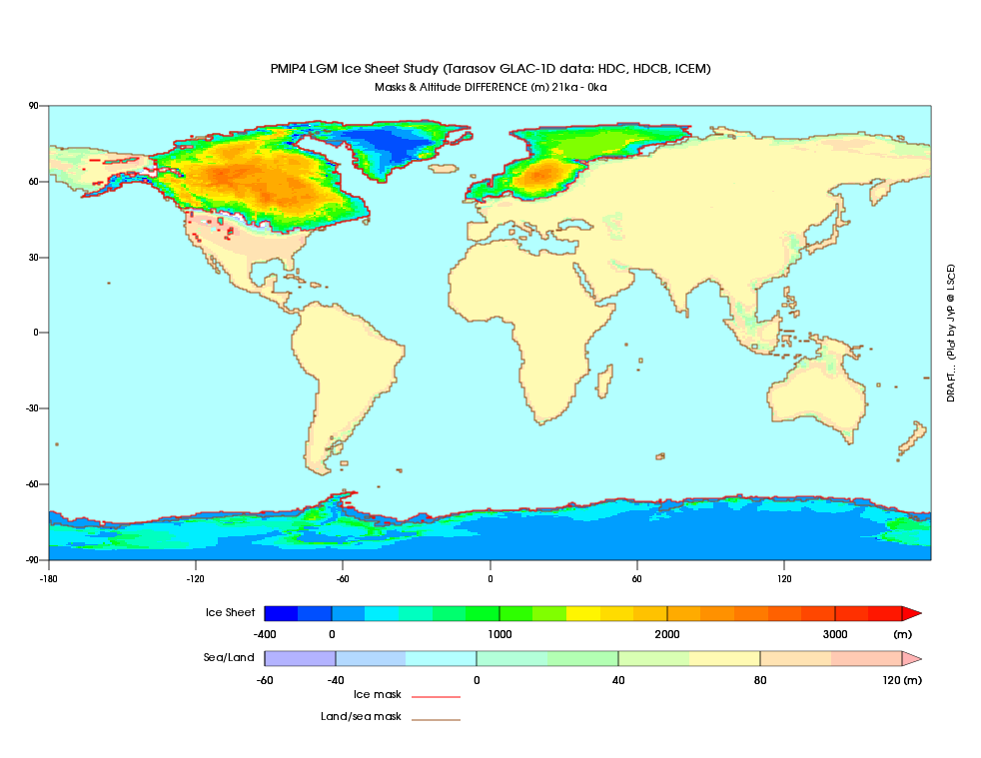 pdf version

Polar projection

PMIP3 blended ice-sheet
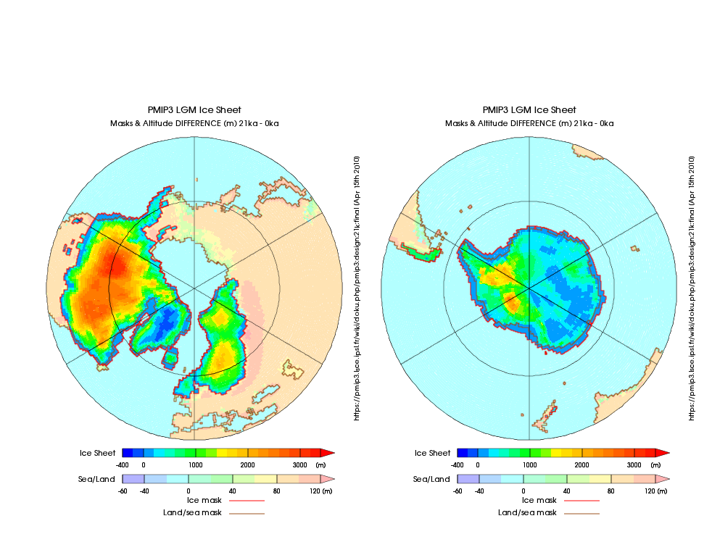 pdf version

Peltier ICE-6G-C for PMIP4
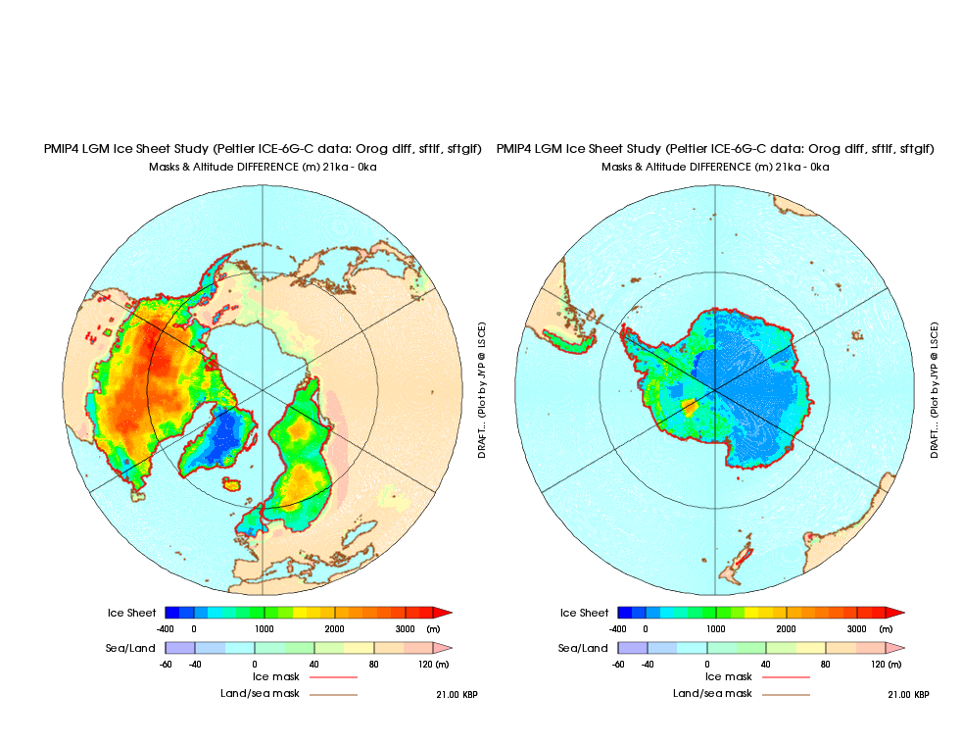 pdf version

Tarasov GLAC-1D for PMIP4
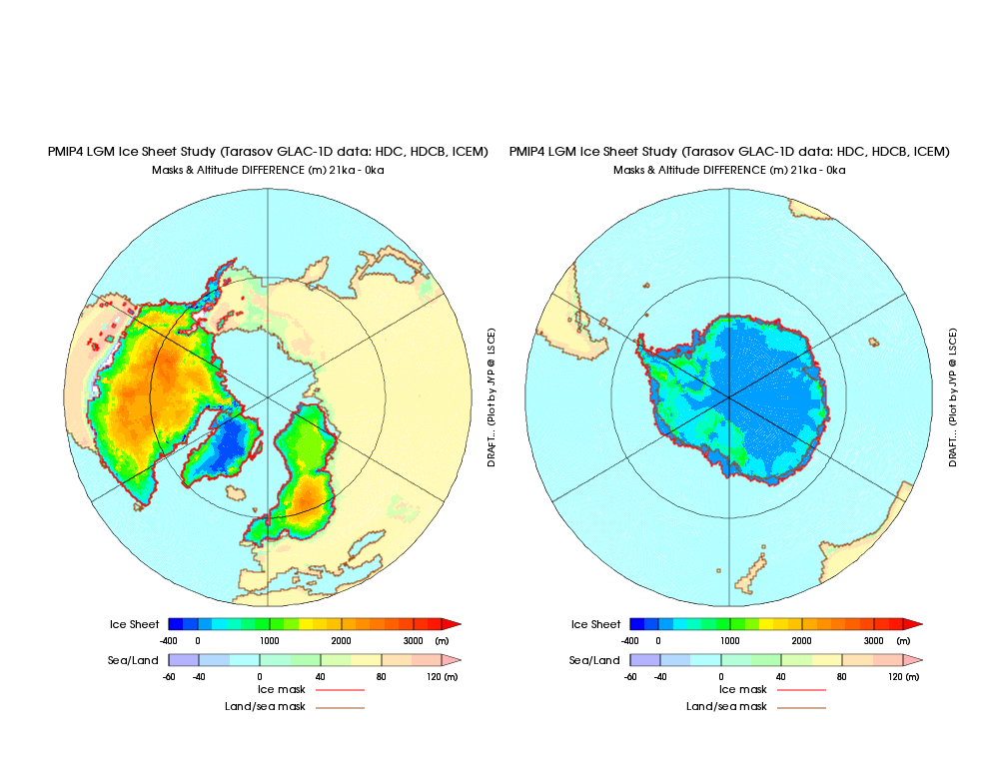 pdf version

[ PMIP3 Wiki Home ] - [ Help! ] - [ Wiki syntax ]

