PMIP-CMIP6 Experimental Design Discussion: Overview and Prioritization
The PMIP4 experimental design available on the PMIP3 wiki has been superseded by the experimental design detailed on the PMIP4 web site
Please submit your comments in the Discussion section at the end of this page

Overview
The following table summarizes the experiments proposed by PMIP for CMIP6. These experiments all build from the DECK experiments and are part of the core of PMIP simulations, which will themselves constitute a basis for other PMIP experiments (sensitivity analyses, transient simulations starting from the core ones). Within PMIP, each PMIP working group will organize their set of simulations, as PMIP also federates focused MIPs such as PlioMIP on the Pliocene climate, LIGMIP on the Last Interglacial, PAST2K on the last two millennia. For all these periods the model to be used is the same as the one used for future climate projections. Therefore depending on the groups the model will be only atmosphere-ocean coupled models or Earth System models. The reference for the analyses will be the CMIP6 preindustrial simulation.
Table: summary of proposed experiments. In yellow: PMIP3/CMIP5 experiments. In green: new experiments for CMIP6. The PMIP3/CMIP5 experiment names in the ESFG nomenclature are indicated in italic below each period name.
Click on the table for a bigger version
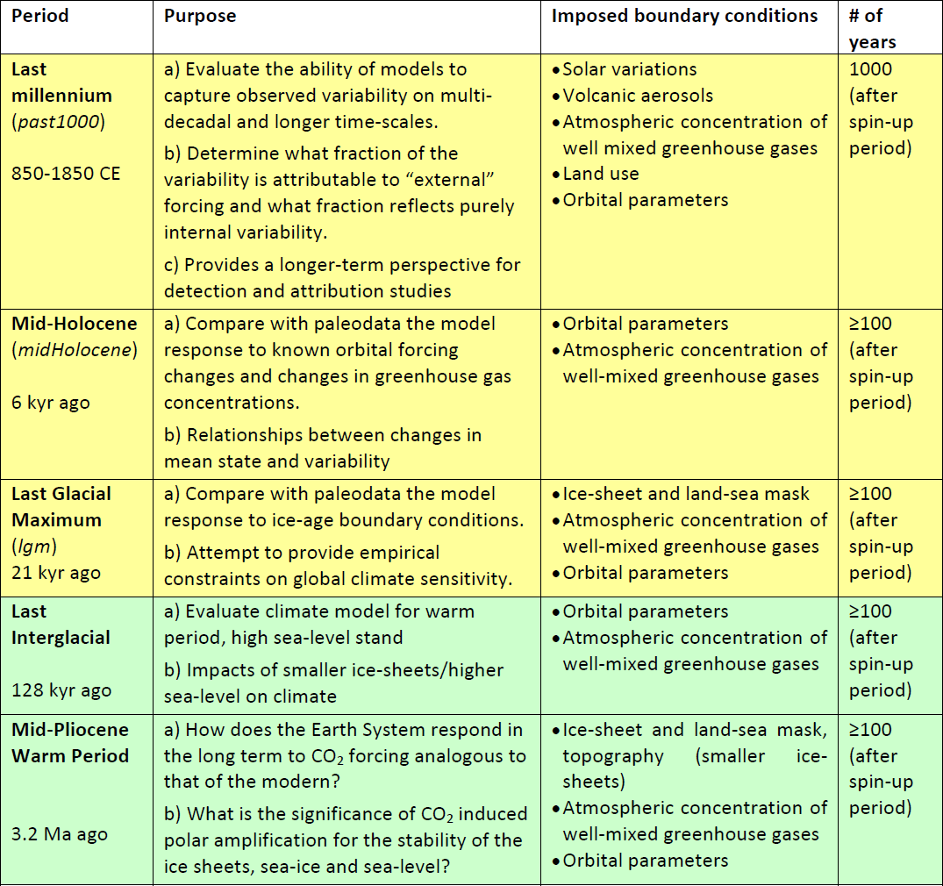Click for a bigger version
The next phase of PMIP will make use of the PMIP3 boundary conditions whenever possible. A major foreseen evolution is related to the interactive computation of the dust cycle in atmospheric models, for which changes in vegetation also have to be taken into account. PMIP2 and PMIP3 recommended the use of either interactive vegetation or prescribed pre-industrial vegetation. For PMIP4, those models which include an interactive representation of the dust cycle will have to account for changes in vegetation. We invite the modelling groups to indicate their intentions and opinion about this particular topic in the discussion section at the bottom of this page.

Prioritization
Each proposed PMIP experiment for CMIP6 can be run independently, because they focus on different time periods. The midHolocene and lgm experiments have been the focus of PMIP since its start and allow for an evaluation of new model versions since the first atmosphere-only GCMs in PMIP1. We therefore require one of these two simulations to be performed as an entry card to CMIP6-PMIP4 experiments. All five PMIP experiments proposed for CMIP6 have equal priority, each experiment being the core of a set of sensitivity experiments to be run within PMIP. The organization of the PMIP experiments w.r.t CMIP6 is given in the figure below.
Click on the figure for a bigger version
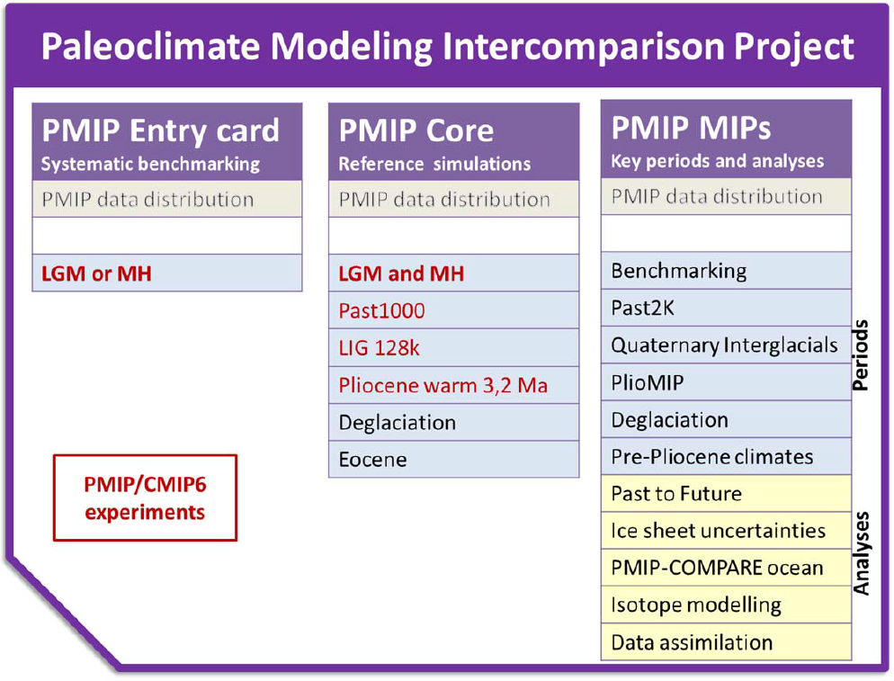Click for a bigger version

Timeline
Ideally past1000 should be run before the historical simulations.
All other experiments can be run as soon as the reference simulation in DECK is run.

[ PMIP3 Wiki Home ] - [ Help! ] - [ Wiki syntax ]

