Experiments Status

PMIP3 Status
The following table gives a quick overview of the PMIP3 participating groups and the status of the experiments they are running.
For more information, visit the PMIP3 Expected Experiments page.
Please get in touch with Jean-Yves Peterschmitt if you want to:
- add your model to this page (i.e. let us know that you will be participating to PMIP3)
- update your group information on this page (and the other related wiki pages)
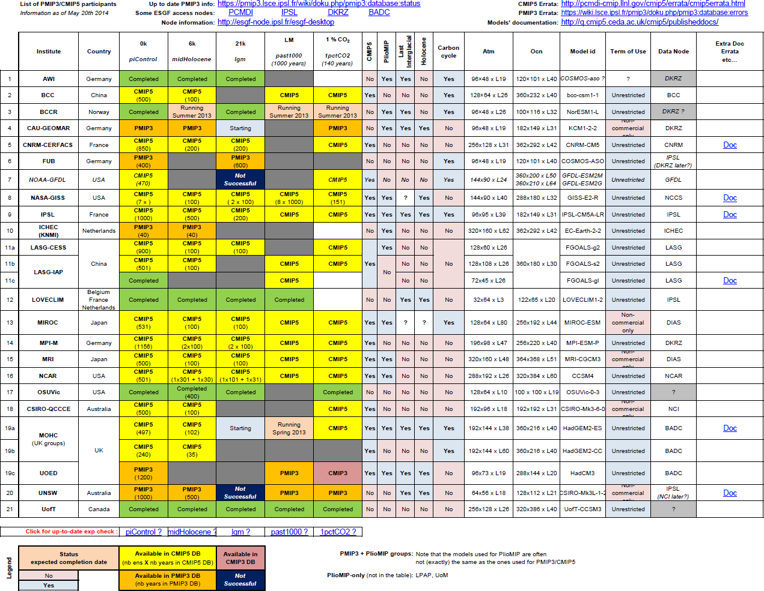
Download the pdf version of this table

past1000 experiment status and BC
The following table gives a detailed view of the past1000/LM experiment status and which Boundary Conditions were used by the participating groups
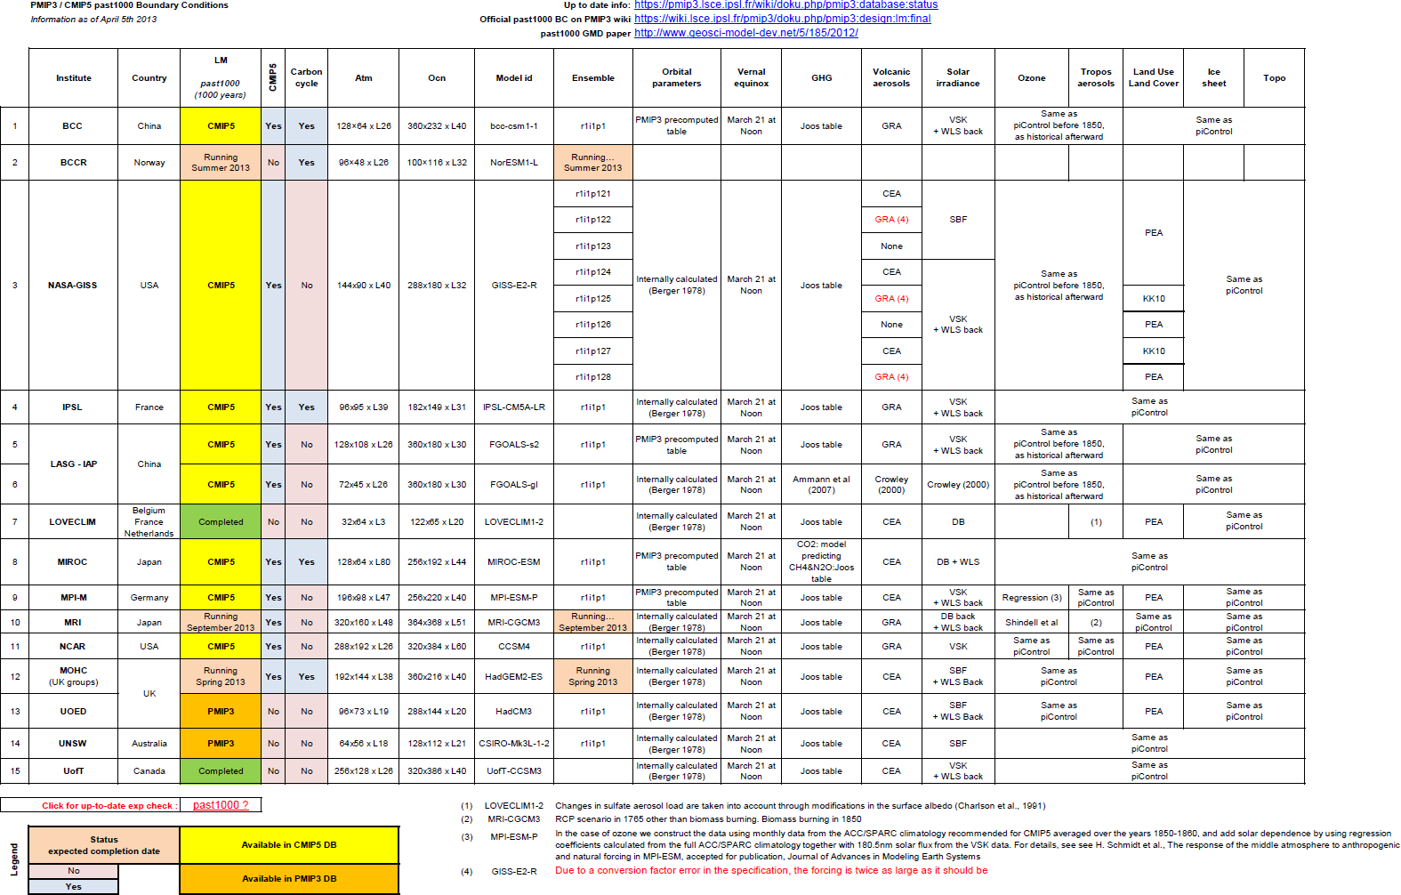
Download the pdf version of this table

CMIP5 DB status
The following links will give you the status of the full CMIP5 DB (the intersection with the PMIP3 DB is just a small subset of CMIP5)
- Number of available datasets: model versus experiment
- Number of available datasets: experiment versus model

[ PMIP3 Wiki Home ] - [ Help! ] - [ Wiki syntax ] - [ Top ]

