Go to ⇒ [ PI ] - [ 6ka ] - [ 21ka ] - [ LM ] - [ LI ] - [ Plio ]

Last Millennium Experimental Design
Page in progress: this is not the final version!
Use the discussion panel at the end of the page for comments
The basic principle is that we should strive to include all relevant transient forcings over this period if the functionality exists in the model, noting that conformability with the CMIP5 controls and 20th Century transient is crucial.

Boundary conditions

Summary of Last Millennium boundary conditions
 | PMIP3 | Alternative solution
Orbital parameters | Annually varying (850-1850) (Table provided if not internally calculated) | 1850 values or same as Pre-Ind CMIP5 control [ ecc = ] - [ obl = ° ] - [ peri-180° = ° ]
Date of vernal equinox | Mar 21 hr 0 | same as CMIP5 control
Trace gases | Annually varying (850-1850) (Table provided) | constant at CMIP5 control levels [ CO2 = ppm ] - [ CH4 = ppb ] - [ N2O = ppb ] - [ CFC = ] - [ O3 = ]
Volcanic Aerosols | Multiple reconstructions (of AOD, Effective Radius, Mass)
Solar irradiance | Multiple reconstructions (default TBD)
Ozone | solar related variations (parameterised as function of change in solar irradiance - Drew Shindell) | same as pre-Ind control
Aerosols | biomass burning changes???? | same as pre-Ind control
Vegetation | Land use conversion (forests to C3/C4 crops) (Pongratz, 2009, Foley and Ramunkutty). Available from WDCC-Hamburg (http://cera-www.dkrz.de/WDCC/ui/Entry.jsp?acronym=LAND_COV_scen_800_1699) | No change from Pre-Ind control
Ice sheets | No changes from Pre-Ind control
Topography and coastlines | No change from Pre-Ind control
Please use the discussion panel to comment this table!

Initial conditions

Additional information

Total Solar Irradiance
The following figure (click to get the full-size image) has been provided by Johann Jungclaus (MPI-M Hamburg)
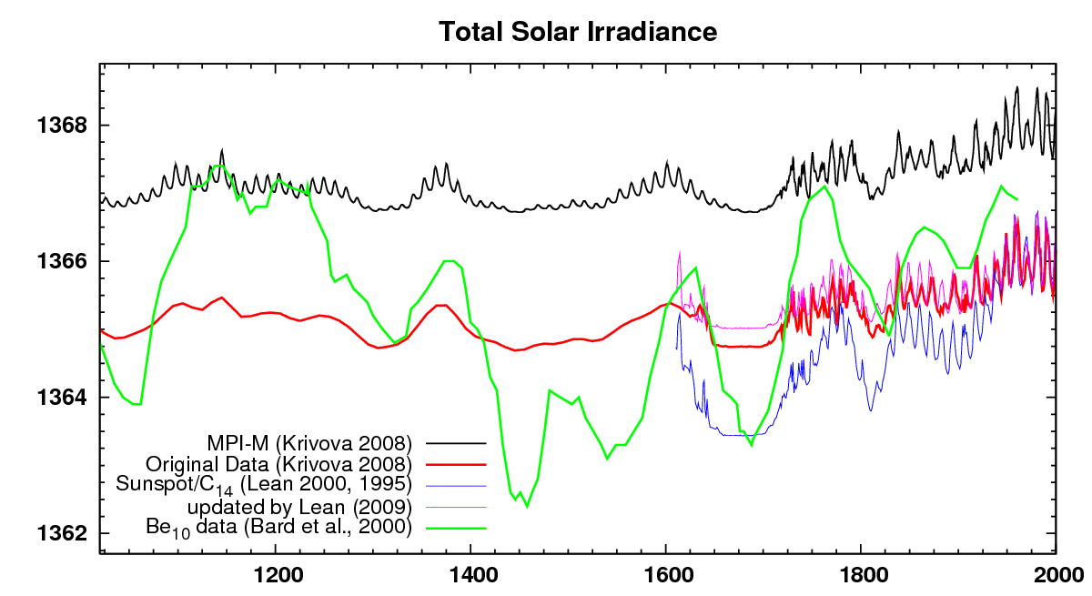Click to get the full-size image
Time series of TSI (Wm-2) from 800AD to 2000. For the COSMOS (MPI-M) Millennium simulations (black curve), a 11 year cycle was added for consistency over the entire period.
Notes: We will impose an 11 year cycle on pre-sunspot reconstructions for consistency of the spectrum of natural variability. Additionally, we will give a spectral set of irradiance changes based on modern variability observed by satellite (Lean).
Candidate reconstructions: Krivova, Steinhilber, new Bard?, (TBD)

Volcanic Forcings
Issues: compatability of eff. rad, zonality, height distribution with modern satellite (Sato) data.
Candidate datasets: Crowley, Ammann - differences in thresholds for significant eruptions, peak forcing etc. Need merged/consistent fields. (Ammann)

Reconstructed evolution of trace gases
The evolution of CO2, CH2, N2O over past 2 millennia table has been provided by Fortunat Joos (University of Bern). Methods and references are provided in the downloadable file.

[ PMIP3 Wiki Home ] - [ Help! ] - [ Wiki syntax ] - [ Top ]

